IT24103490

Wickramasinghe H.A

IT2120 - Probability and Statistics

Exercise

1. . Assume that the time taken to bake a batch of cookies is normally distributed with mean 45 minutes and standard deviation 2 minutes.

(i) . Generate a random sample of size 25 for the baking time.

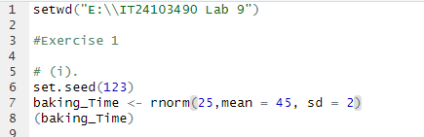

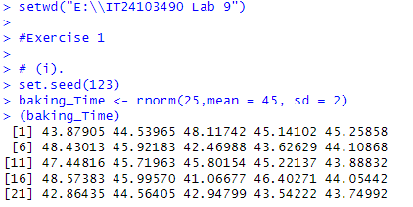

(ii) . Test whether the average baking time is less than 46 minutes at a 5% level of significance.

